# CS 255 System Design Document Template

## UML Diagrams

### UML Use Case Diagram

### UML Activity Diagrams

### UML Sequence Diagram

### UML Class Diagram

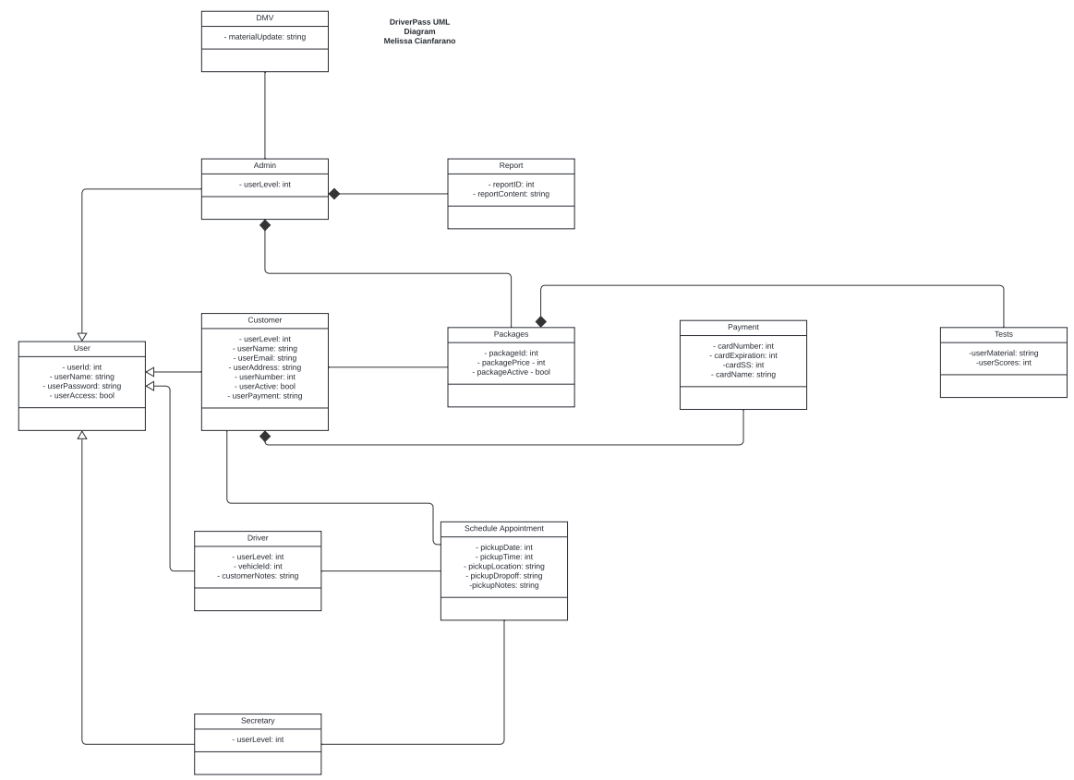

## Technical Requirements

* Hardware Requirements DriverPass:
  + Power source
  + Internet
  + Server
  + Network Cables
  + Monitor
  + Keyboard
  + Mouse
  + Printer
* Hardware Requirements Customer/Employee:
  + Power source
  + Desktop/Laptop/Phone
  + Internet
* Software Requirements DriverPass:
  + Operating System
  + DriverPass software
  + Security Software
  + Database Software
  + Web Browser
* Software Requirements Customer/Employee:
  + Operating System
  + Web Browser
  + Security Software